HAMBLEDEN TENNIS CLUB
www.hambledenlta.org.uk
SUMMER 2019 NEWSLETTER
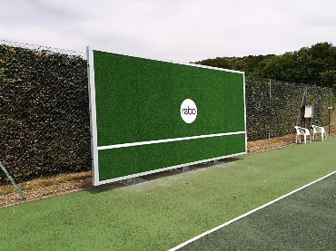

Outcome of EGM
Thank you to everyone who attended the EGM on 18 March and/or voted on the future of our courts. All feedback was carefully considered by the Committee, and sincerely appreciated. Further quotations are being obtained to deliver a broader range of options available to us. More details to follow.
Forthcoming events
Ladies Fun Tournament – Friday 26 April 0930-1100 – contact Ness Hill: chris_and_ness_hill@yahoo.co.uk
Ladies sponsored tournament organised by Tennis Angels – details to follow
Burrows Farm Cup – Sunday 9 June – starting 1000 - £10 per member which will include food & drinks
Strawberries & Pimms (& tennis!) – Wednesday 3 July – from 1800
August Bank Holiday brunch – Monday 26 August – sign up with Erna Rubens (erna@rubens.org)

Club sessions
Sunday mixed club sessions – 1030-1200
Wednesday mixed club sessions – from 1800 – commencing 24 April with wine & nibbles – a collection box for contributions towards monthly wine & nibbles will be available
Friday ladies club sessions – 0930-1100
Mens club sessions – starting late April. Contact Graham Reid for details jgreid29@btinternet.com

Membership fees
Annual membership runs from 1 April to 31 March each year. So the 2019/20 subs are due and you can renew online in the Members area of the website. Please note that annual subscriptions for Juniors has increased to £25 per year. We offer a £5 discount for renewal membership received before 30th April (except for Juniors). Send renewal enquiries to Heather Symons, Treasurer (heathersymons16@hotmail.com).
Future memberships
We are delighted that we continue to have a healthy membership size, with our adults & seniors seeing an increase in membership numbers. However, with our Rebo practice wall, lovely club house and future resurfacing, we would like to let more would-be members know.
If any Club member has some marketing experience and could offer us a few hours of their time, please contact Erna Rubens (erna@rubens.org).
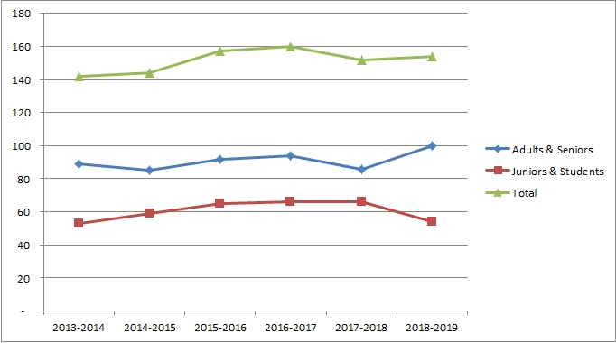
Wimbledon Ballot
Thank you to everyone who opted in to the Wimbledon Ballot. We have now been allocated tickets.
Our Wimbledon draw, giving you the opportunity to purchase Wimbledon tickets will take place on Sunday 5 May at 1030 at the club session. Only paid up members will be eligible for the draw. Do come along and if successful you will be given first choice of dates. Subscriptions are paid from 1 April.
Note: new members can still be eligible for the draw on 5th May if they have paid their membership fees and become a BTM (you can opt in after you join).

Winter Matches – results so far
OLTA (Oxfordshire) ladies doubles division 4 - Finished 8/12
OLTA (Oxfordshire) midweek ladies doubles division 2 - We finished top of this division
Bucks ladies supervets division 1 -so far we have won 3, drawn 1 and lost 1. Likely to be placed 3rd in the division.
Coaching
Coaching will continue to be provided by our Head Coach, Chris Marshall, Kate Peel of Tennis Angels and Mandy Nall. See the website for details.
Safeguarding & Welfare policies
The Committee has updated its safeguarding and wellbeing policies. Details are available on the website.

